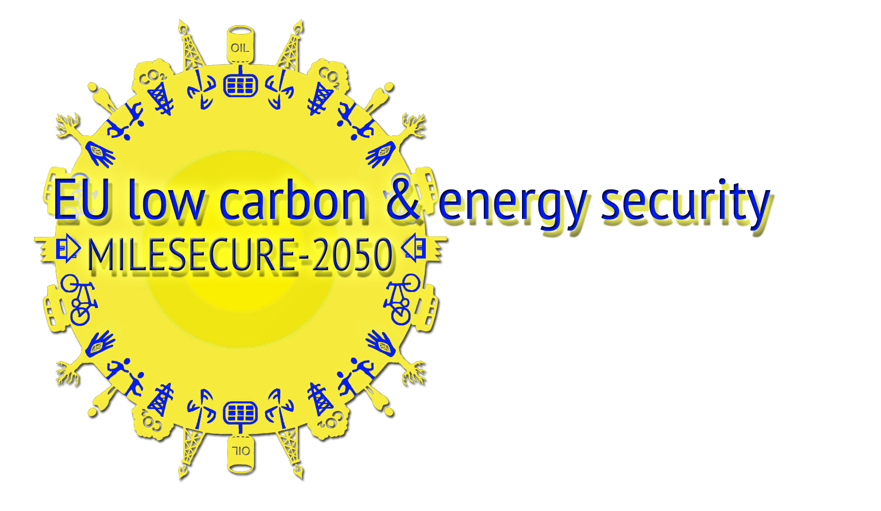
MILESECURE-2050
Multidimensional Impact of the Low-carbon European Strategy on Energy Security, and Socio-Economic Dimension up to 2050 Perspective

SSH.2012.2.2-2 – 320169

INTERNATIONAL SEMINAR

"THE HUMAN FACTOR IN ENERGY TRANSITION & SECURITY TOWARDS 2050
Multidimensional Knowledge, Innovative Models,
Effective Policies”
Tuesday, 15 December 2015
University Foundation, 11, Rue d’Egmont - 1000 Brussels
09.15 -17.30

Please, fill up the form and
send it by e-mail to MILESECURE-2050 Project Secretariat

Registration Desk at the UNIVERSITY FOUNDATION will be open from 08.30 to 09.10
In front of the Meeting Room Félicien Cattier (Ground Floor)

REGISTRATION FORM

Name/Surname:

Position:

Organisation:

Address:

Zip code: Town: State:

Tel.: e-mail:

I authorize the Politecnico of Turin and MILESECURE-2050 Secretariat to collect, store and use this data. (Italian Law no. 196 of June 30, 2003)

Signature: ________________________________________________________

I wish to participate:
(please, cross the box of the Session and Workshops you wish to attend)

OPENIN SESSION

December 15, 2015 - 9.15-11.30

WORKING SESSIONS Potentiality, limits and perspectives of MILESECURE-2050

Workgroup 1  Multidimensional Knowledge  12.00-13.30 |  | Workgroup 2  Innovative Models  12.00-13.30
Workgroup 3

Effective Policies
12.00-13.30
LUNCH

Dietary special request
Please, specify: __________________________________________________

ROUND TABLE

December 15, 2015, 14.30-16.30

Secretariat
Project MILESECURE-2050
http://www.milesecure2050.eu/
For information and registration to the initiative, please contact:
info@milesecure2050.eu - federica.borio@polito.it

